

Project Quality Management

PJM 6135

Individual Assignment 5

Title: Analysis & Causation of defects in M&M sample

Rahul Iyer

Professor Name: Kamyar Shahrooz

1. **QUALITY MANAGEMENT TOOLS TO STUDY CAUSATION**

Out of the seven quality management tools, three tools are very effective while studying causation- Fishbone or Ishikawa diagram, Scatterplot and the Pareto chart (used in the first lab assignment).

1. Fishbone diagram

The Fishbone diagram is also known as the cause and effect diagram. As the name suggests, it creates a relation between the effect by exploring all the possible causes. The team involved in this process performs brainstorming to ensure that all the different major, minor possibilities are taken into account to identify the root cause(s)

Or major factor(s) that has led to the inconsistency or non-conformance of the product/process. Doing so, establishes a systematic approach for problem-solving and determining the reason for the poor quality.

1. Scatterplot

Scatterplot is used to examine if a pattern exists between two variables- an explanatory variable and a response variable. If it does exist, scatterplot provides an interpretation of this pattern graphically. The explanatory and response variables’ behaviour are analogous to the Fishbone diagram’s causes and resulting effects respectively. The analysis on quality is implemented through numerical (quantitative) data, available on variables. Utilization of continuous data improves the accuracy of scatterplot analysis. Although scatterplot does not directly give the cause of a quality problem, it correlates with an explanatory variable that would be very beneficial to determine the cause.

1. Pareto chart

The underlying principle used in the Pareto chart is that 80% of the problems are caused due to 20% of the reasons. This chart is basically a bar graph that plots the frequency of defects categorically in a descending order of frequency. This assists the reader or interpreter to analyze the results and identify major causes almost instantaneously. A vertical axis on the left determines the percentage of total frequency. The area coming under 80% (usually encompassing 20% of the cause-categories) is explored with high priority to gain significant quality improvements in a short time.

1. **COMPARISON BETWEEN FLOWCHART AND FISHBONE DIAGRAM**  
   The following is a comparison between two quality control tools- flowchart and fishbone diagram.

|  |  |  |
| --- | --- | --- |
| **Sr. No.** | **FLOWCHART** | **FISHBONE DIAGRAM** |
| 1. | A flowchart is a visual representation of a process, system or an algorithm. | A fishbone diagram is a visual representation of potential causes of a problem under consideration. |
| 2 | The purpose of a flowchart is to record, plan and communicate a complicated process, system or an algorithm in a simple and concise manner. | The purpose of fishbone diagram is to determine the root cause of a problem or defect. |
| 3 | Flowchart utilizes different shapes symbolizing different meanings such as rectangular boxes, diamond-shaped boxes, arrows to define the step, a decision, sequence of flow respectively. | Fishbone diagram consists of a head with the problem, a backbone that extends from the head to represent causes with the help of arrows. |
| 4 | Causation is very complicated, lengthy and time-consuming to study using flowchart. | Fishbone diagram can be easily used to study causation by performing brainstorming. |
| 5 | The preparation of flowchart does not require many people, a small group of 2 to 3 members can easily create one. | Many subject matter experts, experienced members form a team to perform brainstorming- a prerequisite to the development of a Fishbone diagram. |
| 6 | Flowchart is easy to create, consuming very little time and effort. | The fishbone diagram has a lot of effort, opinions involved and hence, more time-consuming than flowchart. |

1. **FLOWCHART FOR DATA COLLECTION & ANALYSIS ON M&M SAMPLE**

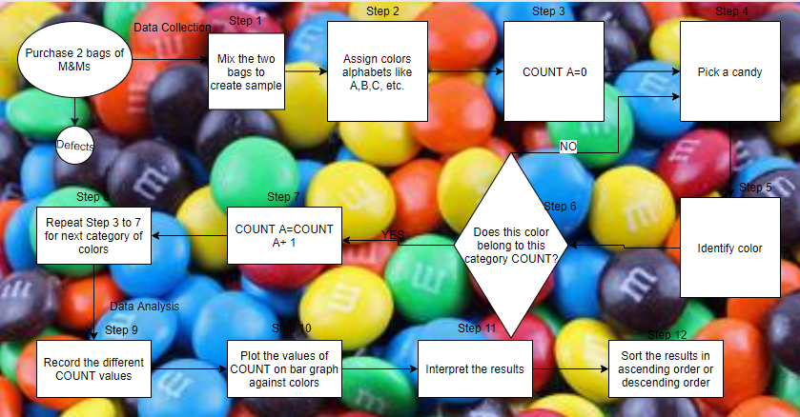

Fig 3.1 Data collection and analysis on M&M sample categorically

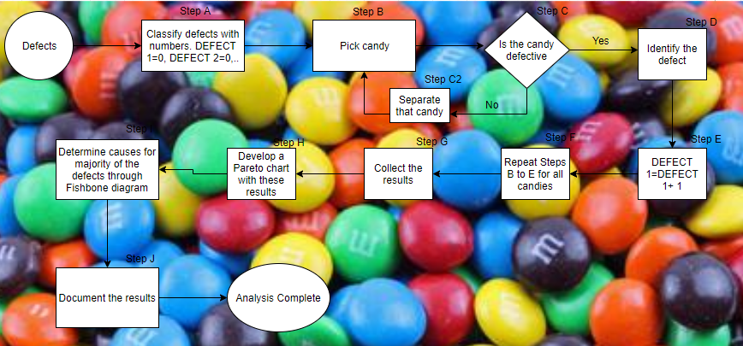

Fig 3.2 Data collection and analysis to determine defects quantitatively

1. **FISHBONE DIAGRAM TO DETERMINE THE ROOT CAUSE OF MOST FREQUENT DEFECT**

The most frequent defects in my sample of M&M candies was the misprint ‘m’ defect. It constituted almost 64% of the total defects.

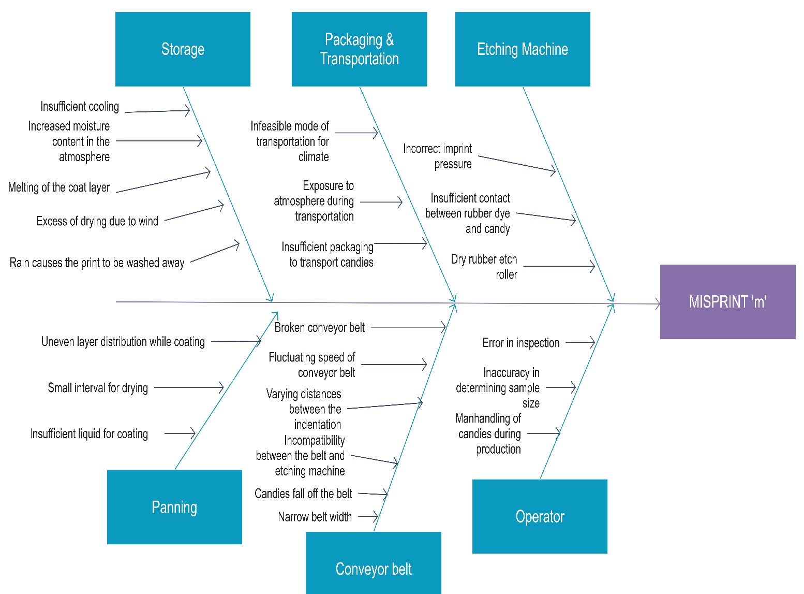

Fig 4.1 Fishbone diagram to determine root cause of misprint ‘m’ defect

1. **QUALITY TOOLS APPLICATION TO ADMISSION DEPARTMENT OF A COLLEGE**

Students find it very difficult to apply to universities outside their own countries. Often, they approach educational consultants that help them with the process by charging a fee. As an example, when I decided to pursue Master’s in Project Management in the US, I did not know exactly where to begin, the requirements and the application process. On approaching consultants and taking guidance from seniors, I began understanding the entire system from application to submission of documents.

Based on this experience, I can say that the quality tools can ease the student’s experience in terms of tracking the admission process.

1. Checksheets must be utilized to summarize the requirements of the college and the student’s progress so far to meet those requirements. The requirements must be ordered chronologically to avoid confusion in the student’s mind.
2. Another quality tool that can be used for understanding the student’s perspective is drawing a Pareto chart based on the feedback available on different websites. Targeting the queries of most students and developing a better response that would mitigate that problem would benefit the college along with the students.
3. Scatterplots in group could be used to calculate the correlation coefficient between nationality (explanatory variable) and frequency of applications (response variable). Regions with high values must be given more attention and priority. Colleges may often find ways of reaching the targeted region by conducting seminars and/or online conferences to ensure that they do not have trouble completing the admission process as they account for a large section among the applicants.

**Reference:**

Cause Analysis Tools. (n.d.). Retrieved October 18, 2018 from <http://asq.org/learn-about-quality/cause-analysis-tools/overview/overview.html>

Hessing, T. (2014, April 17). Scatter Diagrams (Plots), Analysis & Regression. Retrieved October 18, 2018 from <https://sixsigmastudyguide.com/scatter-analysis-regression/>

Rouse, M. (2015, February). Fishbone diagram. Retrieved October 18, 2018 from <https://whatis.techtarget.com/definition/fishbone-diagram>